Fauquier Community Theatre

2011-2012 Season of Shows

www.fctstage.org

Godspell
Sponsored by WPRZ 88.1 Praise Radio

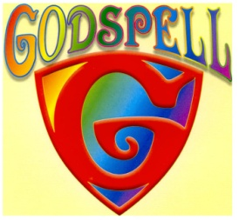
Oct. 13-16, 21-23, 27-30

Thurs., Fri., & Sat. 8 PM, Sundays 2 PM
Adults $17, Seniors/ Students $15
Thurs., Oct. 13 – Teachers and Students half-price

Prepare ye for GODSPELL, the beloved classic from Stephen Schwartz, the Grammy® and Academy Award®-winning composer of WICKED and PIPPIN. Enjoy all the good gifts of one of the most enduring shows of all time. Raise your spirit with the Tony®-nominated score filled with the popular hits Day By Day, Learn Your Lessons Well & Turn Back, O Man. This timeless tale of friendship, loyalty and love has touched the hearts of countless theatergoers all over the world–and now you can join the celebration as FCT performs the greatest story ever told. So come sing about love – at GODSPELL.

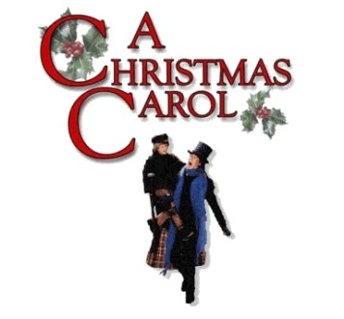
A Christmas Carol
Sponsored by McKinsey Development
(Integrated Marketing Communications)
Dec. 2-4, 9-11, 16-18
Fridays & Saturdays 8 PM, Sundays 2 PM
Adults $15, Seniors/ Students $13

Join the ghosts of Christmas Past, Present and Future as they lead the
miserly Ebenezer Scrooge on a journey of transformation and redemption.

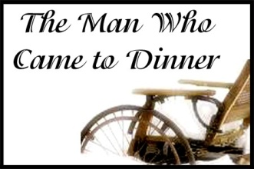
The Man Who Came to Dinner
Sponsored by John Clark with Middleburg Mortgage
(www.mymortgageprofessional.com)

Jan. 13-15, 20-22, 27-29
Fridays & Saturdays 8 PM, Sundays 2 PM
Adults $15, Seniors/ Students $13

While on his way to dinner at a suburban family’s home, Sheridan Whiteside, an insufferably arrogant radio personality, accidentalyy falls and breaks his hip. A tumultuous six weeks of confinement follow, during which Whiteside monopolizes the living room, and along with an off-beat cast of characters who come to visit him, proceeds to drive his hosts round the bend! This hilarioiusly witty sattire willl have you in stitches!

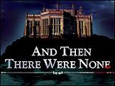
And Then There Were None
Sponsored by Dicover Pubications
Mar. 2-4, 9-11, 16-18
Fridays & Saturdays 8 PM, Sundays 2 PM
Adults $15, Seniors/ Students $13
In this classic Agatha Christie whodunit, eight guests who have never met each other before are lured by a cryptic invitation to a deserted island and marooned, along with the two house servants. An odd cluster of statuettes -- ten little soldiers -- sits on the mantelpiece. A nursery rhyme embossed above them tells how
each of the ten soldiers meets his death, "until there were none."
As the group assembles for cocktails before dinner, a mysterious
voice accuses each of having gotten away with murder -- and then
the group starts finding one of their own murdered one by one.
Can the group discover the shocking identity of the murderer
before there are no suspects remaining?

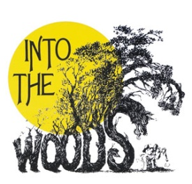
Into The Woods
Sponsored by Airlie Conference Center
Age appropriate – 14 and up
May 4-6, 11-13, 18-20
Fridays & Saturdays 8 PM, Sundays 2 PM
Adults $17, Seniors/ Students $15

An ambivalent Cinderella? A blood-thirsty Little Red Ridinghood? A Prince Charming with a roving eye? A Witch...who raps? They're all among the cockeyed characters in James Lapine and Stephen Sondheim's fractured fairy tale. When a Baker and his Wife learn they've been cursed with childlessness by the Witch next door, they embark on a quest for the special objects required to break the spell, swindling, lying to and stealing from Cinderella, Little Red,
Rapunzel and Jack (the one who climbed the beanstalk). Everyone's wish is
granted at the end of Act One, but the consequences of their actions return to
haunt them later, with disastrous results. What begins a lively irreverent fantasy
in the style of The Princess Bride becomes a moving lesson about community
responsibility and the stories we tell our children.

The Fauquier Community Theatre
4225 Aiken Drive
Warrenton, VA 20187
Located in Vint Hill
540-349-8760
tickets@fctstage.org

