FAUQUIER COMMUNITY THEATRE

2019 - 2020 SEASON SUBSCRIPTION FORM

**BUY FIVE SHOWS AND GET THE SIXTH ONE FREE!!**

*_____________________________________________________________________________*

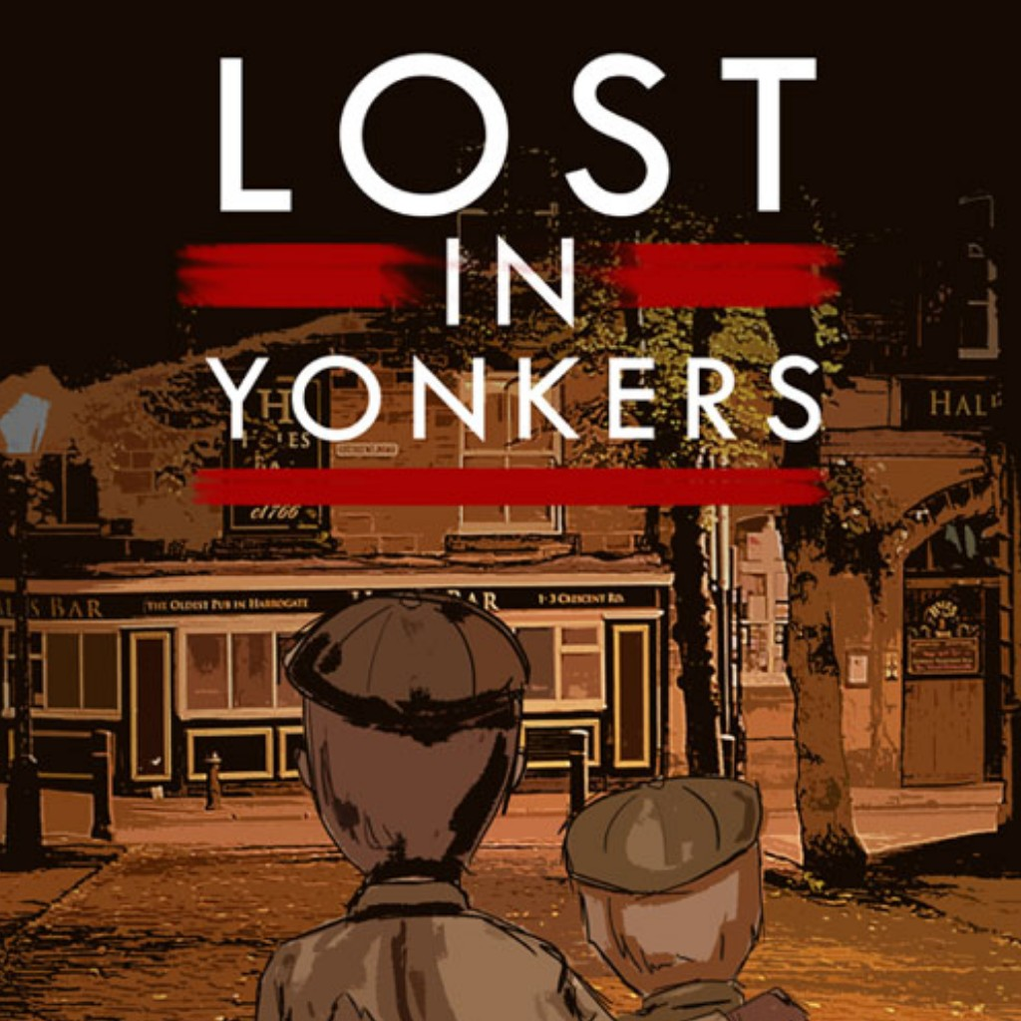

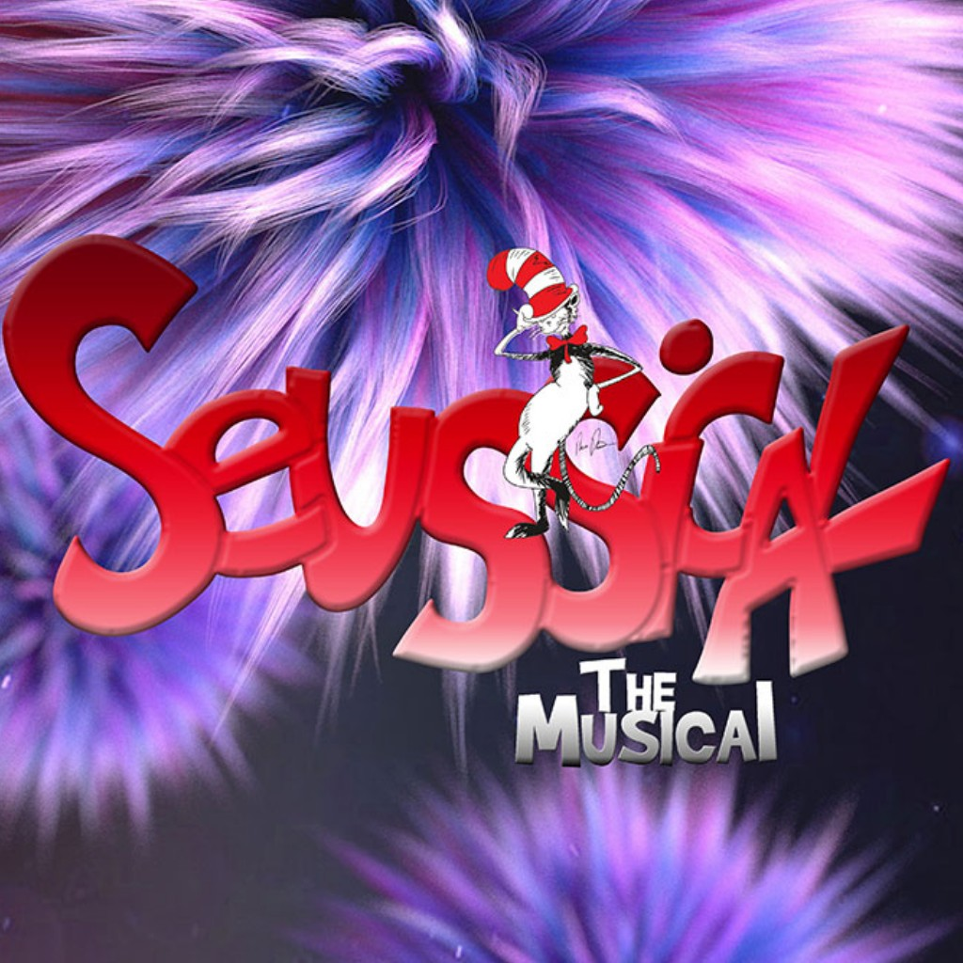**SEUSSICAL LOST IN YONKERS**

August 30, 31, September 1, 2019   
October 4, 5, 6, 2019

September 6, 7, 8, 2019 October 11, 12, 13, 2019 September 13, 14, 15, 2019 October 18, 19, 20, 2019

**THE BEST CHRISTMAS   
RABBIT HOLE  
PAGEANT EVER: THE MUSICAL**

November 29, 30, Dec. 1, 2019 January 24, 25, 26, 2020   
December 6, 7, 8, 2019 January 31, February 1, 2, 2020

December 13, 14, 15, 2019 February 7, 8, 9, 2020

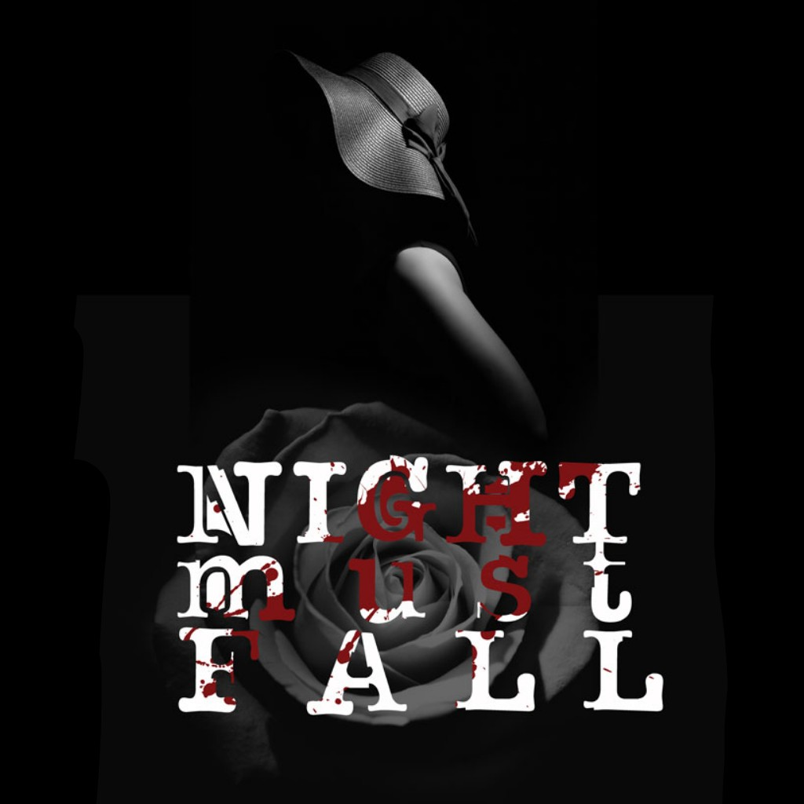**NIGHT MUST FALL JESUS CHRIST**

**SUPERSTAR**March 13, 14, 15, 2020 May 1, 2, 3, 2020   
March 20, 21, 22, 2020 May 8, 9, 10, 2020

March 27, 28, 29, 2020 May 15, 16, 17, 2020

Name: _____________________________________________________________________

Address: __________________________________________________________________

City: _____________________________ State: _______________ Zip______________

Phone: ____________________________________** Email: __________________________

**I wish to purchase:**

________ Adult Season Subscriptions @ $100.00 each for a total of: $____________

**________** Senior Season Subscriptions @ $90.00 each for a total of: $____________

(aged 60 and above)

________ Student Season Subscriptions @ $85.00 each for a total of: $____________

(aged 3-18)

**TOTAL:** $____________

􀂉Check enclosed OR 􀂉Visa 􀂉Master Card 􀂉Discover 􀂉Amex

CC#: _________________________ Expiration Date: ________3 digit # on back of card ______

**Please enclose your check with the above form and mail to:**

**Fauquier Community Theatre** Attn: Ticket Coordinator, P. O. Box 3046, Warrenton, Virginia 20188

Tickets@FCTstage.org www.FCTstage.org 540-349-8760

You will receive a confirmation letter by email when payment has been received. This letter will include individual pass codes that you will enter in the payment section when making reservations online. If you do not have email, please indicate so and your letter will be mailed to you. You may also call or email for your seat reservations prior to each show. We will do our best to give you the seats of your choice. Remember, the earlier you make your reservations, the more likely it is that you will get the seats you prefer.

**Thank you for your support of Fauquier Community Theatre!**

**ENJOY THE SHOWS!**